Department of Secretarial Practice
Report on Interactive session on Logistic Management held on 14-09-2022

The Department of Secretarial Practice organised a Interactive session on 14th, September 2022 for the students of First year B.Com and First BA students at Home Centre, Mangalore. Prof. Hemalatha and Ms.Vidya Bhat, accompanied the students. About 36 students from the Commerce Section and 20 students from the BA availed the benefit.
Mrs. Neetha, Conceptual Manager, Home Centre explained about the logistics management, purchase and sale of their products and personal grooming. It was an interaction session where students had queries on logistic management and management of purchase and sales.
Objectives :
- To reinforce experiential and contextual learning
- To enhance classroom learning by making real world connections.

Outcomes:
- Students Got familiar with Advanced technology for improving the efficiency and profitability of the business
- Students Learnt to improve the overall quality of goods and services
- Assessing Risk Management Plan is one of the important objectives of this programme
- Students also learnt the technique of reducing overhead cost
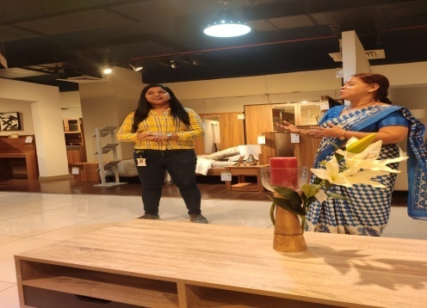
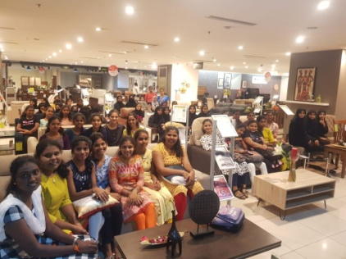
Department of Secretarial Practice
Report of Industrial Visit to Modern Kitchens on 11-10-2022
The Department of Secretarial Practice organised an industrial visit on 11th October, 2022 for the students of First Year B. Com Modern Kitchens, Yeyyadi, Mangalore. Mrs. Vidya Bhat and Raksha Prabhu, Assistant Professors accompanied the students. About 36 students from the Department availed the benefit.
Mrs. Neha, Quality Manager, Modern Kitchens explained about the quality maintenance, production process, branding and sale of their products. It was an interaction session where students had queries Quality Management, management of purchase and sales.
Objectives :
- To acquire practical knowledge on skills required to work in industry
- To develop holistic learning
- To witness live events and activities in a business space
Outcomes:
- The students realized that the core benefit of an industrial visit cannot be replaced by any book or syllabus.
- Students got a platform to enhance their interpersonal skills.
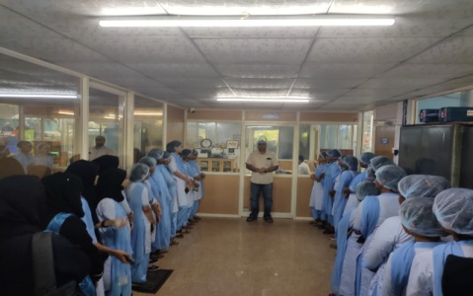
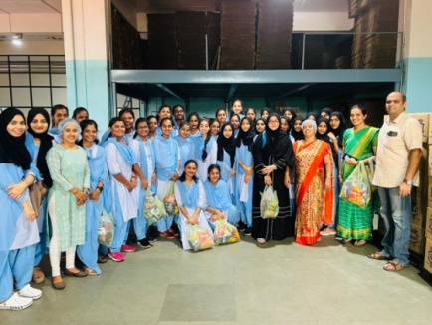
- The students get to see the best practices opted by different companies for similar work.

Department of Secretarial Practice
Report on Swaccha Bharath Abhiyaan on 29- 10-2022

Nature of the activity:
Cleaning Programme by the students and faculty members from the Department of Secretarial Practice
OBJECTIVES:
- To eliminate or reduce Open defecation
- Stop the use / eliminate dumping of plastic which is known to contaminate the water.
The Department of Secretarial Practice in association with Mangalore Prithvi Charitable Trust undertook a Cleaning task of the Bondel Area on October 29, 2022. Mr. Krishnappa, Mr. Ramachandra Bhat, Senior Environmentalists and Mr. Akshay accompanied the students and staff of the College, helped in the cleaning work. The Chairperson of the trust, Ms. Lolakshi Fernandes conveyed to the organizers and participants her best wishes on the occasion and joined them to partake in the event.
Prof. Hemalatha, HoD – Secretarial Practice along with Ms. Vidya Bhat, Assistant Professor, guided the students on the cleaning task.
Thirty students actively participated in the event. The nutritional breakfast was provided by Mr. Praveen, a resident of the locality.
Outcomes:
The students learnt the importance of keeping our environment clean and thus prevent spread of epidemic diseases. The methodology of keeping the premises near to us clean was also learnt

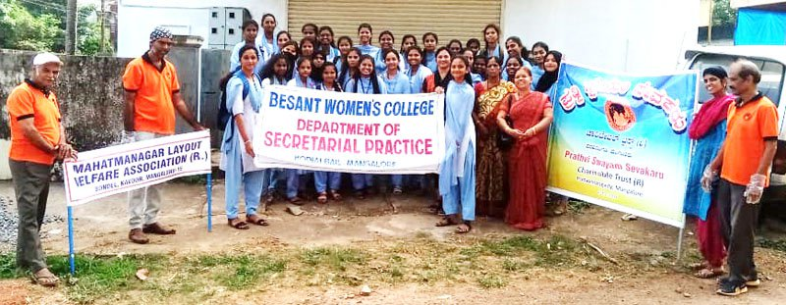

Department of Secretarial Practice
Report on Mock Board Meeting held on 3-11-2022

The Department of Secretarial Practice conducted a mock Board Meeting on 3rd, November, 2022 for the students of Second year B.Com in the college auditorium. Ms.Vidya Bhat and Raksha Prabhu, Assistant Professors monitored and guided the students. About 25 students participated, out of which 8 were Board of Directors and the remaining shareholders.
The students prepared Agenda before the meeting and the discussion were based on the agenda. The secretary noted down the minutes of the meeting. The meeting culminated with the CEO convincing the shareholders that their investments are safe in the company.
Objectives:
- To get a knowledge of Secretarial duties regarding Board Meeting
- To resolve issues and amplify decision making
- To work in a team to achieve measurable goal.
Outcomes:
- The students learnt Secretarial duties regarding Board Meeting
- The students acquired the knowledge of preparing ‘Resolution’
- The students learnt the drafting of Agenda and Minutes of a company
- The students imbibed the knowledge of Organising skills

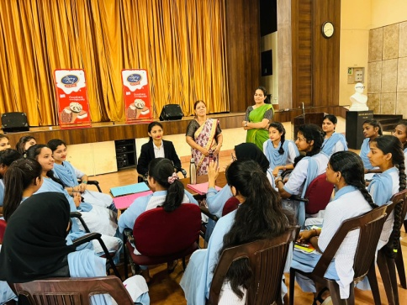
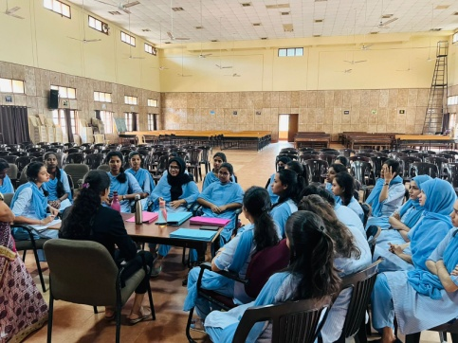

DEPARTMENT OF SECRETARIAL PRACTICE
REPORT ON INDUSTRIAL VISIT TO ODDOOR FARM
10-12-2022
On 10th December, 2022, 200 students accompanied by the faculty members of the department of Secretarial Practice of Besant Women’s college visited the Oddoor Farm, Ganjimutt, Mangalore. This visit provided an inspiring example of the efforts made by Mr. Rajesh Naik to transform 120 acres of barren land into lush green farms. There was a lake in the middle of the property to provide a water resource for the agriculture to sustain. The students got the opportunity to see a variety of cattle breeds with milk vending machine.
Students got the knowledge how the cattle dung and daily wastes would be used to generate bio-gas, which not only helps in generation of electricity but also provides fuel for a generator and cooking. The slurry is a rich source of bio compost and is used to keep the soil organically enriched and fertilized.
Students also learnt a lesson that constant hard work and perseverance pave the way towards success.
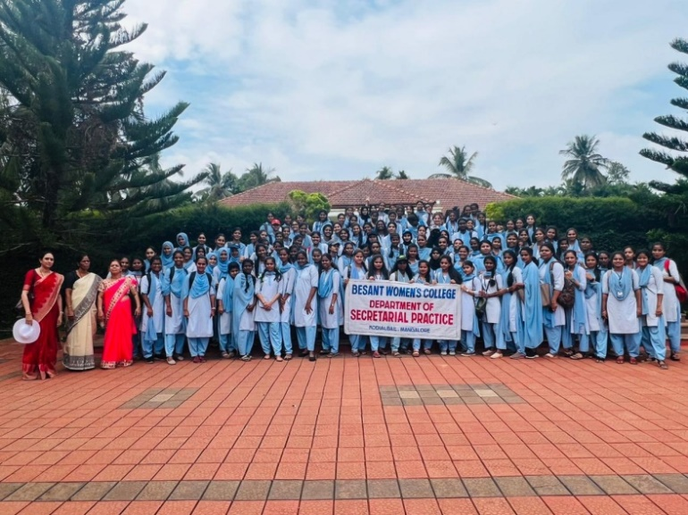

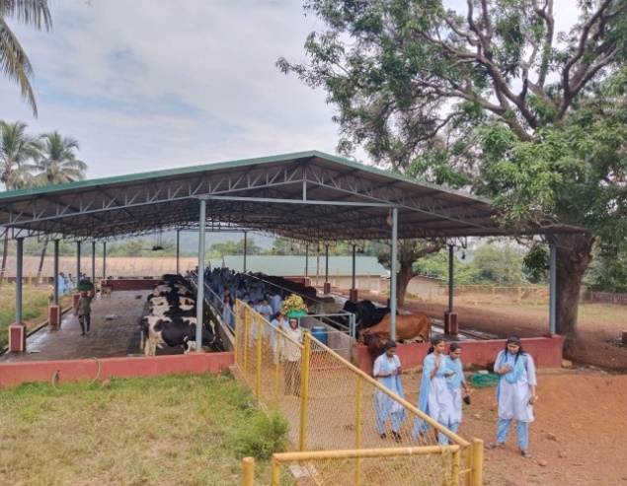
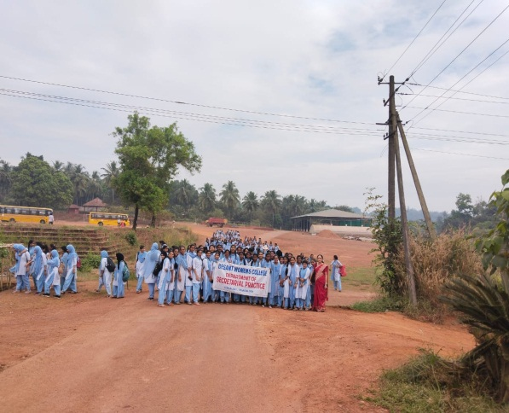
DEPARTMENT OF SECRETARIAL PRACTICE
Report of ‘Knowledge sharing programme- on the topic ‘Salary administration’ held on 19-12-2022
The Department of Secretarial Practice conducted ‘knowledge sharing programme – on the topic ‘Salary Administration’ on 19th December 2022 at 9.30 am in Computer Lab1. Ms. Deeksha, Assistant Professor, St. Agnes College (Autonomous), Mangaluru was the resource person. She shared her expertise on the sub topic “Increment Slab and Encashment of Earned Leave”. Students gained knowledge on calculation of Increment slab, procedure for encashment of Earned Leave and formula for its calculation. At the end of the session students answered the questions asked by the resource person.
Mrs. Hemalatha, HoD of Secretarial Practice, welcomed and introduced the resource person. Ms. Usha Kumari of II BA proposed Vote of Thanks. Mrs. Ranjini, Assistant Professor, Department of Secretarial Practice was present.
Objectives:
- To gain additional information on Increment slab and its calculation
- To acquire more knowledge on the procedure of Encashment of EL
- To learn the application of formula for calculation of Earned Leave Encashment
- To make the students aware of the procedure of salary calculation.
Outcomes:
- Students gained additional knowledge on calculation of Increment slab
- Students learnt the application of formula to calculate encashment of Earned Leave
- They also acquired knowledge on procedure to apply for encashment of EL.

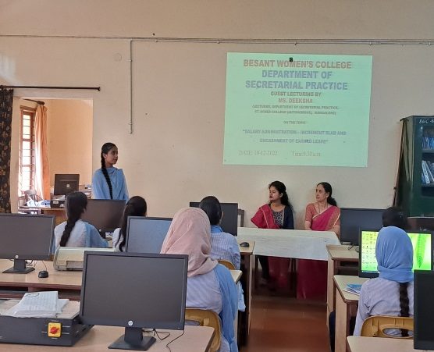
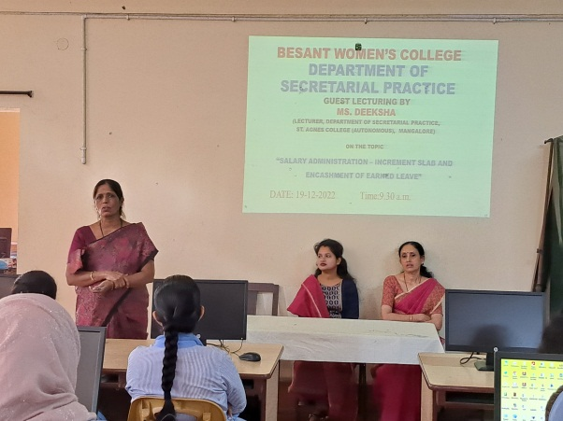

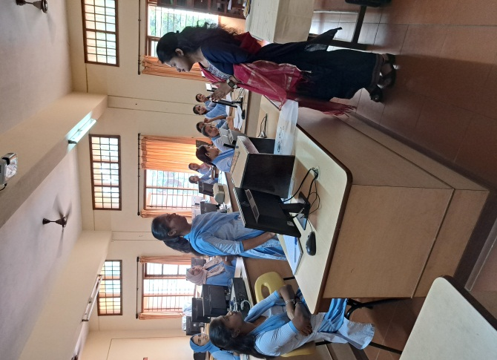
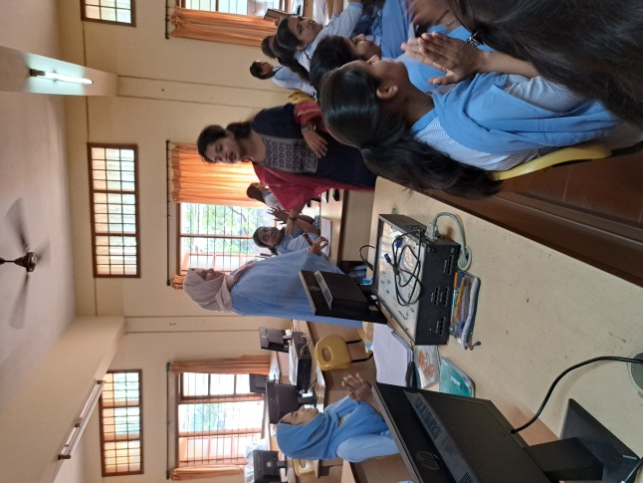
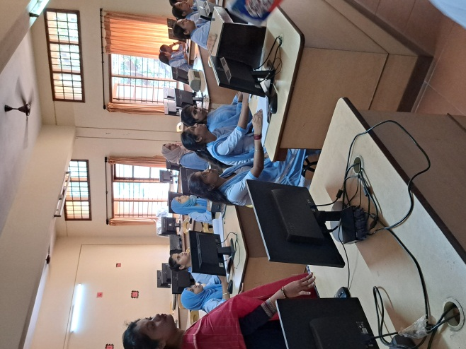

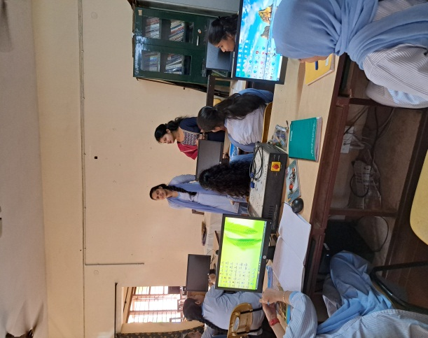

DEPARTMENT OF SECRETARIAL PRACTICE
Report of ‘Fastest Finger’- Typing Speed Competition held on 19-12-2022
The Department of Secretarial Practice organised ‘Fastest Finger’ Typing Speed Competition on 19th December 2022, at 2.30 pm in Computer Lab1. 50 students from different streams took part in this competition. Mrs. Ranjini, Assistant Professor from the department of Secretarial Practice had given the instructions for the competition and explained how to use ‘Typing Master’ software. Mrs. Hemalatha, HoD of Secretarial Practice thanked the participants for their active participation and congratulated the winners.
The Result of the competition:
I Prize - Shama – I BA
II Prize - Hakima Rameeya J - I B.Sc.
III Prize shared by :
Yashasvi – I B.Com. ( 3 ) and
Ashfiya - I BCA

Objectives:
- To check the keyboarding skill with the students
- To check technical skill
- To evaluate student's ability to type fluently and accurately
- To test student’s wpm (word per minute) speed and accuracy.
- To build confidence

Outcomes:
- Students got an opportunity to check their own keyboarding skill
- They got to know their fluency and accuracy in typing

